Unified Robotics II- CS HW1

**SCD** **(System Context Diagram)**

Operator

Shape type output

Push Start

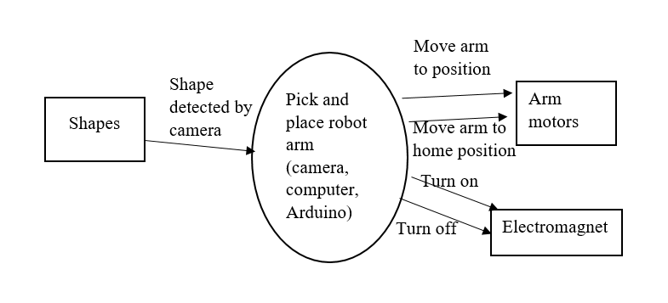

**STD** **(State Transition Diagram)**

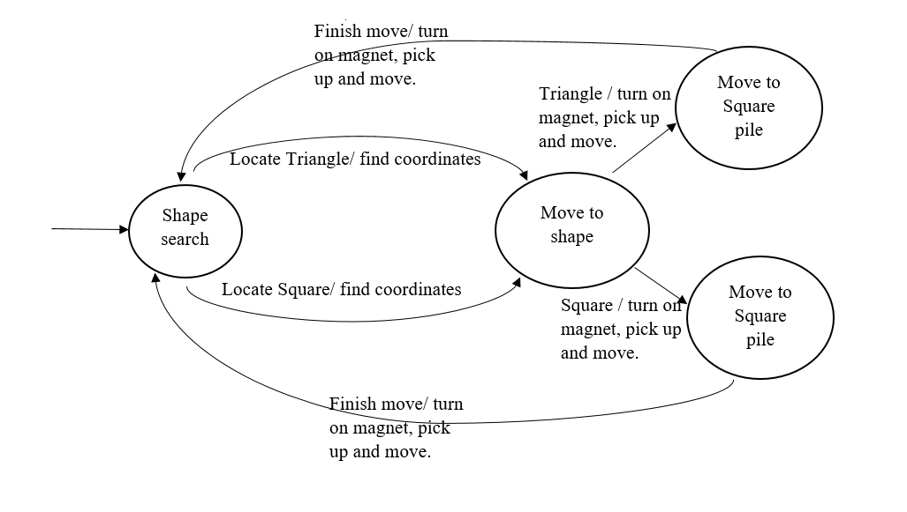

**SqD** **(Sequence Diagram)**

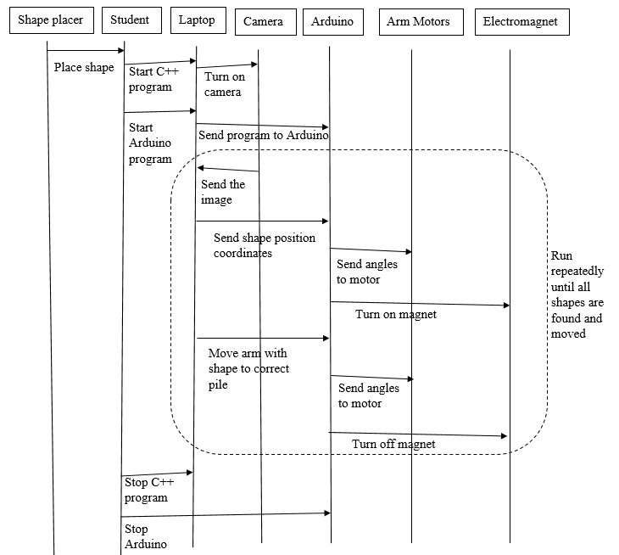

Stop C# program

Return to home

Start C# program

If not shapes are found

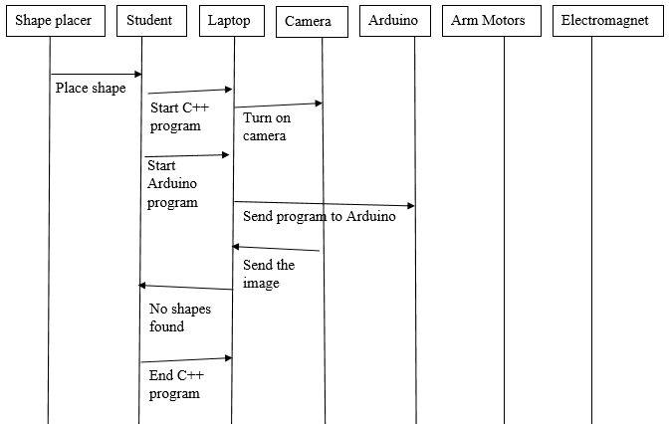

If Arduino fails to connect

